Name: Shipra Patel
B.Voc - Software Development
Roll_no: 08 Div: C

Lab – 3B
Title: Deploy Docker Image from ECR to ECS
Objective:
Use the AWS Console to deploy your Docker image (already pushed to ECR in Lab 3) to a fully managed ECS Fargate service.

Step-by-Step Using AWS Console

Step 1: Confirm Your Image Exists in ECR
Go to the AWS Console → search for ECR
Open your repository (e.g., sample-web-app)
Confirm that sample-web-app:latest exists under Images

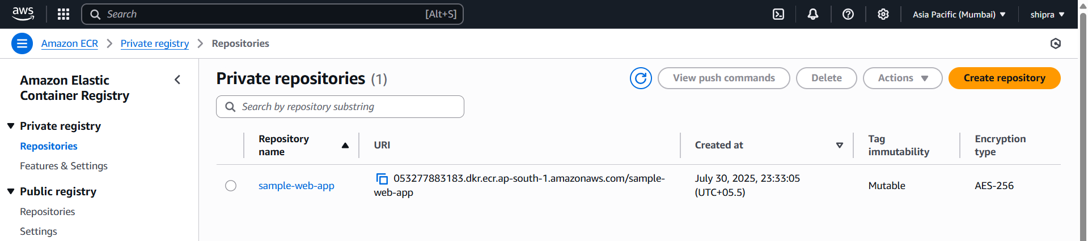

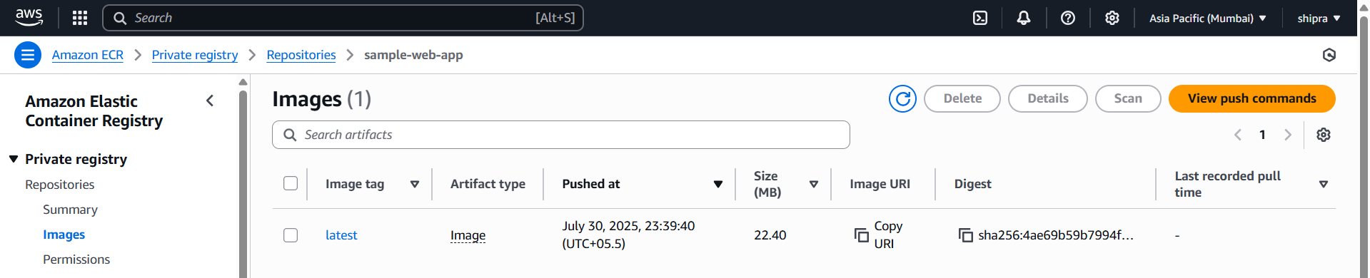

If it's there, you're good to go!

Step 2: Create an ECS Cluster
Go to AWS Console → search for ECS
Click Clusters > Create Cluster
Select “Networking only” (Fargate) → Click Next
Enter a Cluster name: demo-cluster
Click Create
You’ve now created a Fargate-ready ECS cluster.
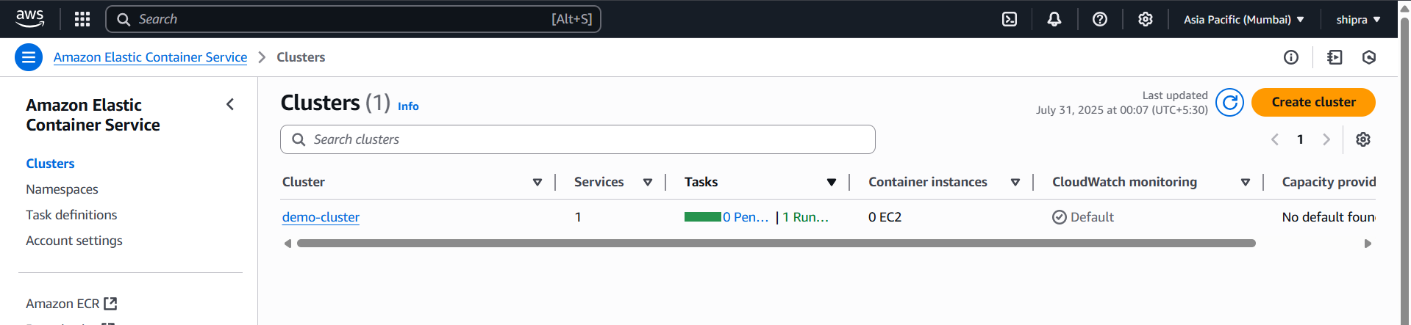

Step 3: Create a Task Definition
Go to Task Definitions > Create new Task Definition
Choose FARGATE > Click Next
Configure Task:
Name: sample-web-task
Task role: (leave default or create new if needed)
Task size:
Memory: 0.5 GB
vCPU: 0.25 vCPU

Add Container:
Container name: web
Image URI:
Go to your ECR repo, copy the full URI like:
605463757083.dkr.ecr.us-east-1.amazonaws.com/sample-web-app:latest
Paste it into the “Image URI” field
Port mapping: container port 80 Click Add, then Create task definition.

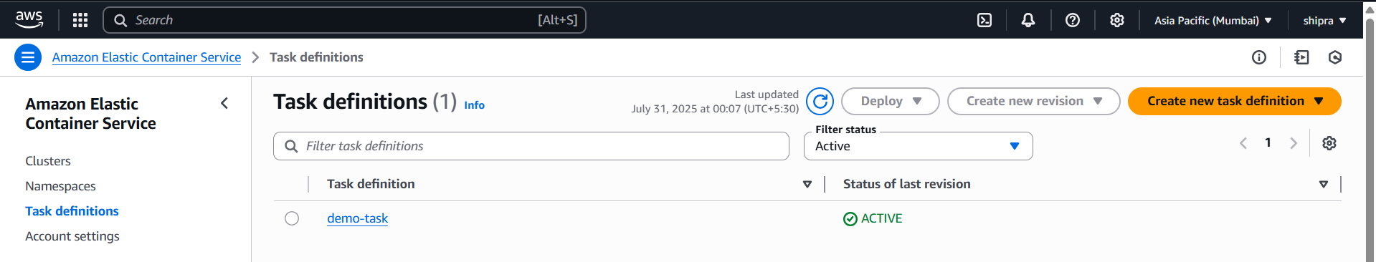

Step 4: Run a Fargate Service
Go to Clusters → click your cluster (demo-cluster)
Click Deploy → Create service
Launch type: FARGATE
Task definition: choose sample-web-task
Cluster: demo-cluster
Service name: web-service
Number of tasks: 1

Networking:
VPC: pick default VPC (if available)
Subnets: pick 2 public subnets • Auto-assign public IP: ENABLED
Security group:
Create new or pick existing
Allow inbound port 80 (HTTP) Click Next, then Create service
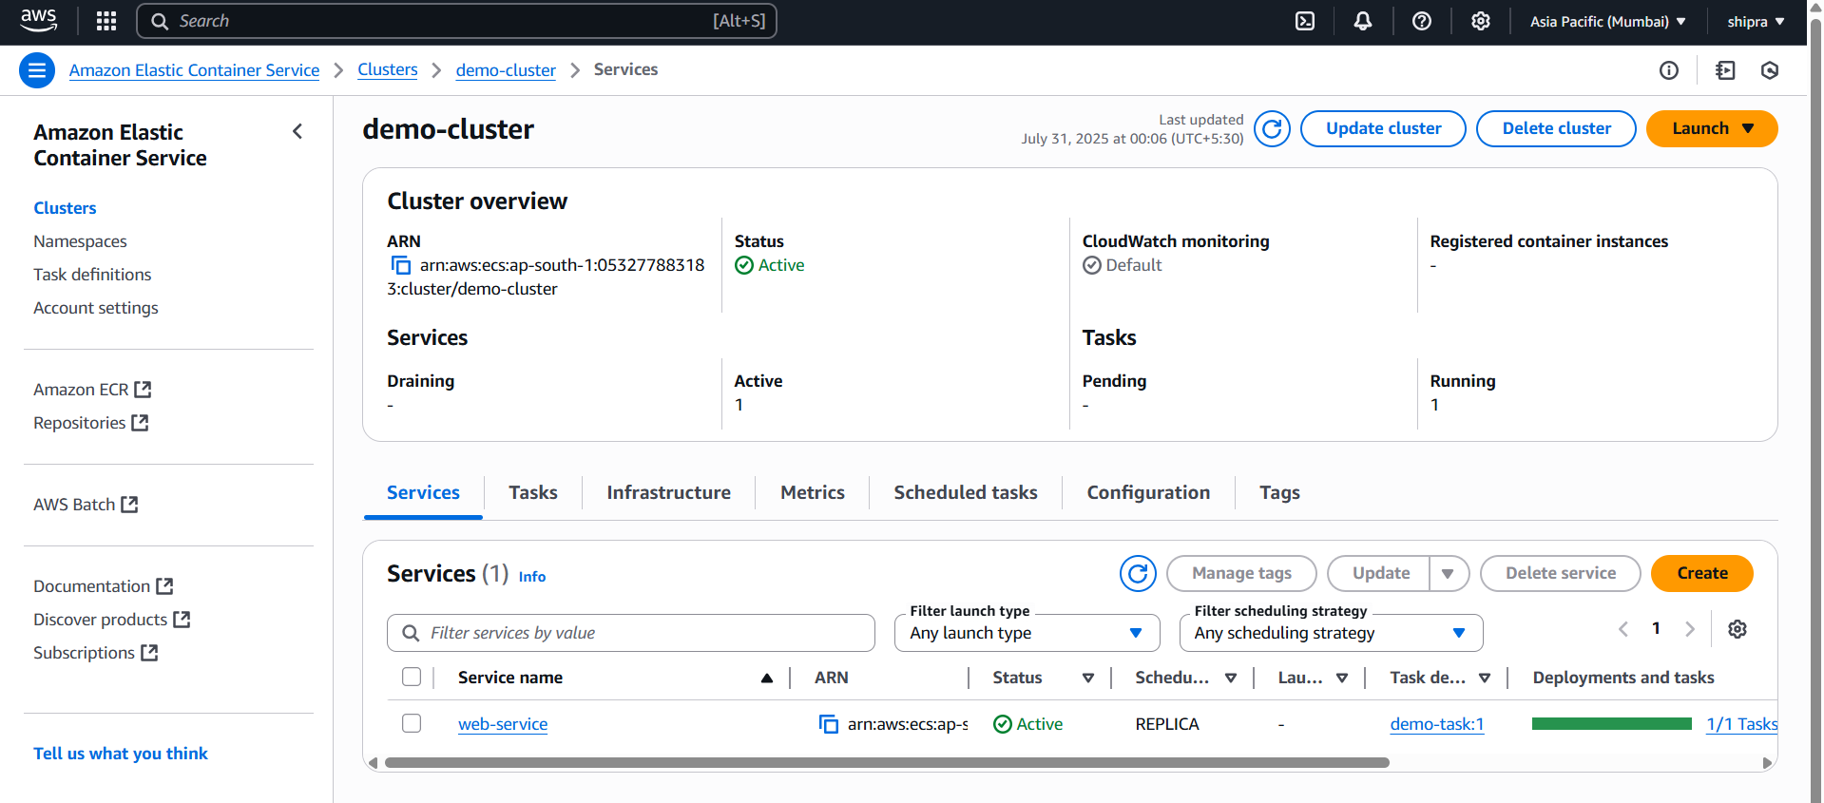

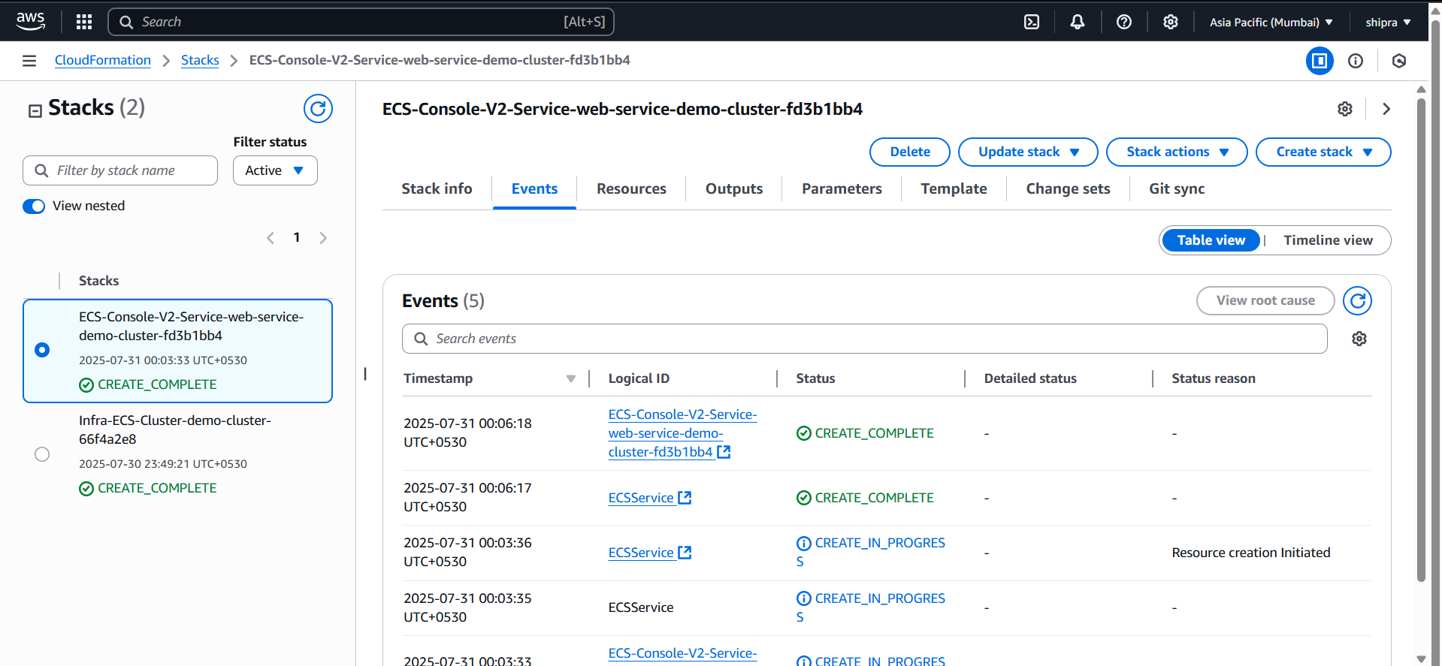

Step 5: Access Your Web App
Go to your cluster > Tasks tab
Click the Task ID
Find the ENI (Elastic Network Interface) → click it

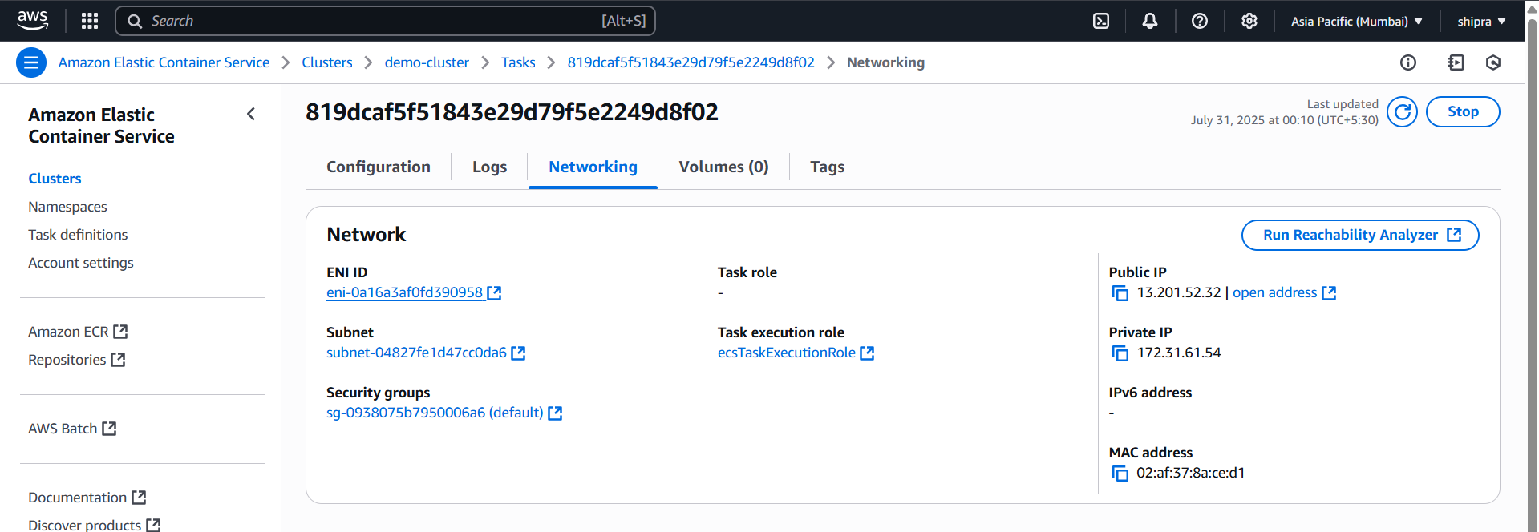

Look under Public IPv4 address — copy it
Paste it in your browser:
http://<public-ip>

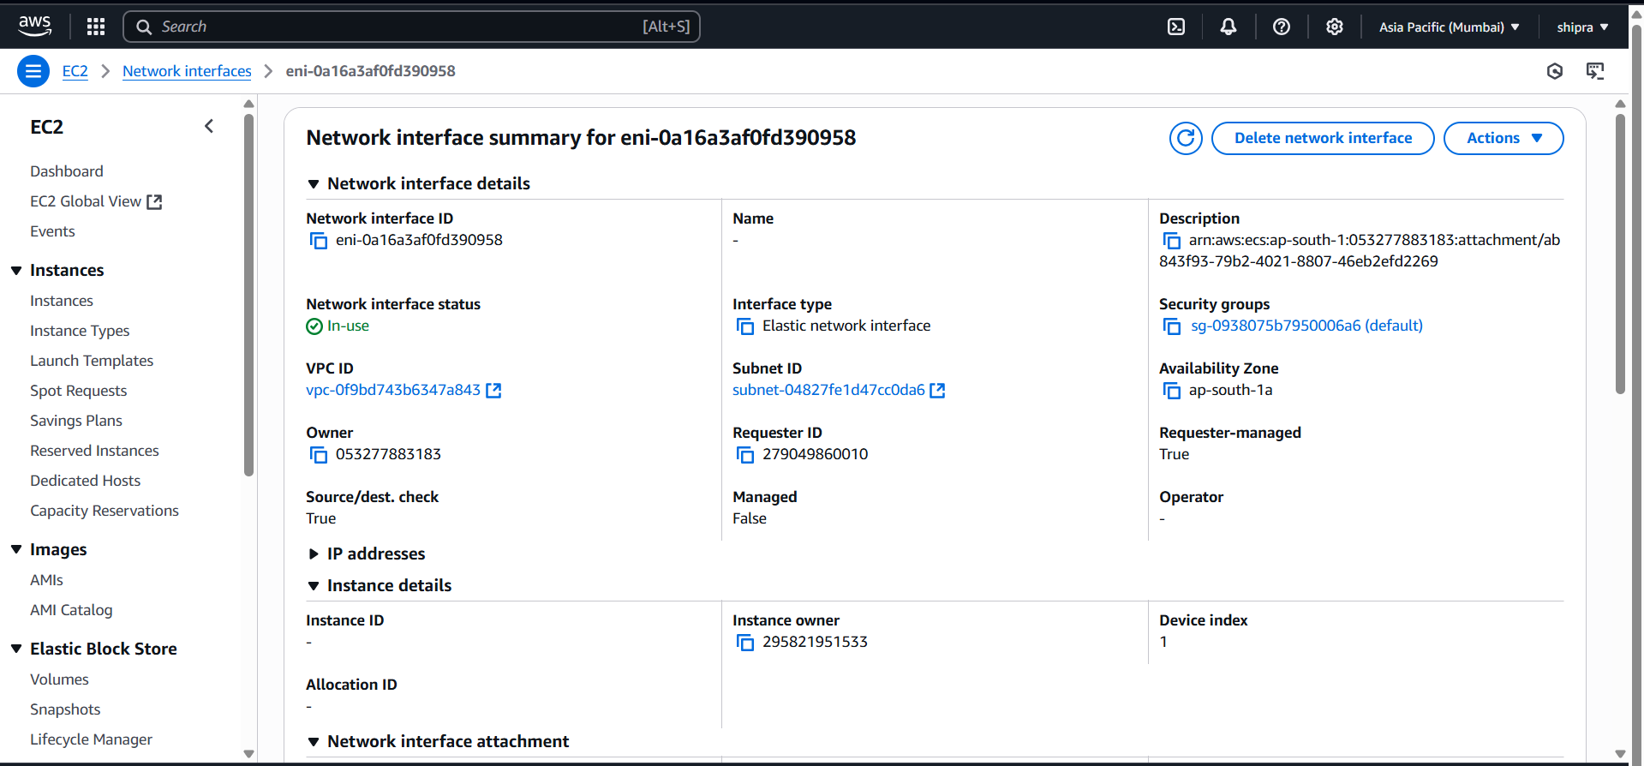

You should see your index.html content served by Nginx via Fargate.

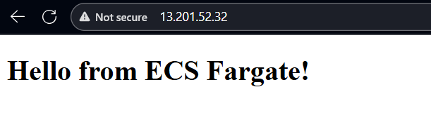
Instructor Remarks
